

**SIMATS SCHOOL OF ENGINEERING**

**SAVEETHA INSTITUTE OF MEDICAL AND TECHNICAL SCIENCES**

**CHENNAI-602105**

**A CAPSTONE PROJECT REPORT**

**IoT Development: Unlocking the Power of Connected Devices**

*Submitted in the partial fulfillment for the award of the degree of*

**BACHELOR OF ENGINEERING**

**IN**

**COMPUTER SCIENCE AND ENGINEERING**

**Submitted by**

**D.PAVITHRA(192210339)**

**S.LIKITHA(192211956)**

**Under the Supervision of**

**R.YUVARANI**

**April 2024**

IOT DEVELOPMENT :

IoT development is the process of developing IoT applications and products that can be controlled remotely and can be used to monitor the connected product's condition or environment via sensors and external data sources. Custom IoT Development is done to meet the specific requirements of a business.

Internet of Things (IoT) development in operating systems involves creating and optimizing operating systems to support the unique requirements of IoT devices. IoT devices are typically small, resource-constrained, and diverse in terms of functionality. Here are some key aspects of IoT development in operating systems:

Examples of operating systems designed for IoT development include Free RTOS, RIOT, Contiki, Zephyr, and Embed OS. Each of these operating systems has its strengths and is tailored to different IoT use cases and requirements.

**SENSORS FOR IOT DEVELOPMENT**

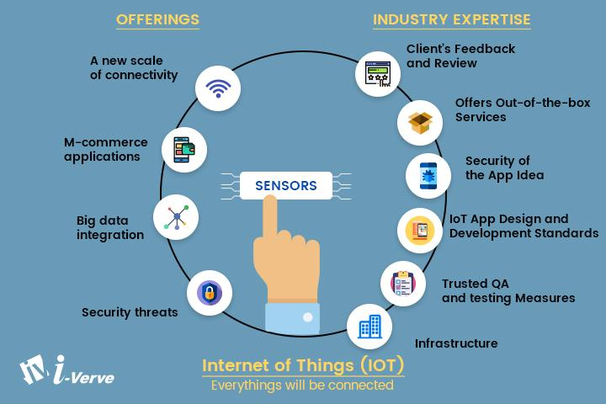

PROBLEM STATEMENT:

* Ensuring the security of IoT devices and networks is a major challenge. Issues include device authentication, data encryption, secure communication, and protection against cyber-attacks.
* Ensuring the security of IoT devices and networks is a major challenge. Issues include device authentication, data encryption, secure communication, and protection against cyber-attacks.
* Managing and analysing the massive amounts of data generated by IoT devices pose challenges in terms of storage, processing, and extracting meaningful.
* IoT devices often collect and transmit sensitive data. Balancing the benefits of data collection with privacy concerns is a challenge that requires robust privacy policies, consent mechanisms, and data anonymization techniques.
* The lack of standardization and interoperability among different IoT devices and platforms can hinder seamless communication and collaboration. Developing common standards is crucial for widespread adoption.
* As the number of IoT devices continues to grow, scalability becomes a significant challenge. Systems must handle the increasing volume of data and connections efficiently.

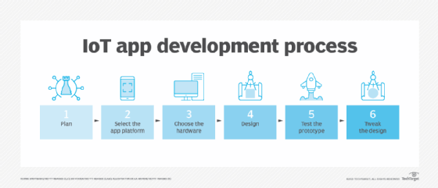

PROPOSED DESIGN WORK

**1.Identifying the key components:**

Internet of Things (IoT) development in operating systems involves creating and optimizing operating systems to support the unique requirements of IoT devices. IoT devices are typically small, resource-constrained, and diverse in terms of functionality. Here are some key aspects of IoT development in operating systems:

* Resource Efficiency:

IoT devices often have limited processing power, memory, and storage. Therefore, IoT operating systems need to be lightweight and resource-efficient to run effectively on these devices.

* Real-time Capabilities:

Some IoT applications require real-time processing, such as industrial automation and control systems. Operating systems for IoT may include real-time capabilities to meet the timing constraints of these applications.

* Security:

Security is a critical concern in IoT development. Operating systems for IoT should implement robust security features to protect data, devices, and networks. This includes secure boot, data encryption, and secure communication protocols.

* Connectivity:

IoT devices rely on various communication protocols to connect and exchange data with other devices or the cloud. IoT operating systems should support a variety of communication standards, such as Wi-Fi, Bluetooth, Zigbee, LoRa, and others.

* Scalability:

IoT ecosystems can vary widely in size, from a few devices to millions. Operating systems should be scalable to accommodate different scales of IoT deployments.

* Device Management:

IoT operating systems often include features for remote device management and over-the-air updates. This allows for efficient maintenance, monitoring, and updating of IoT devices deployed in the field.

* Compatibility:

IoT operating systems should be compatible with a wide range of hardware architectures and devices. This flexibility is essential given the diverse nature of IoT devices.

**2.Functionality**

IoT development involves a wide range of functionalities to enable the creation and deployment of connected devices and systems. The functionalities for IoT development can be categorized into various aspects, including device connectivity, data management, security, and user interaction. Here are key functionalities for IoT development

* Device Discovery: Discovering and connecting to other devices on the network.
* Communication Protocols: Implementing communication protocols like MQTT, CoAP, HTTP, or custom protocols based on the application requirements.
* Wireless Connectivity: Supporting various wireless technologies such as Wi-Fi, Bluetooth, Zigbee, LoRa, and cellular networks.
* Sensor Integration: Integrating and interfacing with a variety of sensors and actuators to collect and act upon data.

**3.Architecture design:**

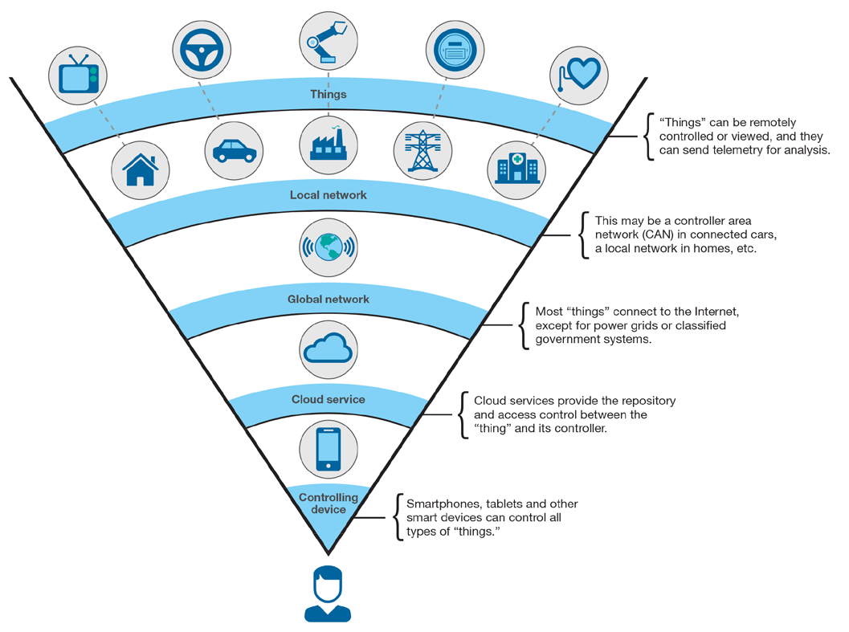

When designing architecture for IoT (Internet of Things) development, several key considerations must be taken into account to ensure scalability, security, efficiency, and reliability. Here's a high-level overview of architectural design principles for IoT development:

* **Device Layer:** This layer includes IoT devices such as sensors, actuators, wearables, and other edge devices. The architecture should support various types of devices with different communication protocols and capabilities. Design considerations include power efficiency, data collection, and device management.
* **Connectivity Layer**: This layer handles communication between devices and the cloud. It includes protocols such as MQTT, CoAP, and HTTP for data transmission. Designing for reliable, low-latency communication is crucial, considering the potentially intermittent and constrained network environments IoT devices operate in.
* **Cloud Infrastructure:** The cloud infrastructure provides storage, processing, and analytics capabilities for IoT data. It involves components like databases, message brokers, and compute resources. Design for scalability to handle large volumes of data, as well as for elasticity to accommodate varying workloads.
* **Data Processing and Analytics**: This layer involves processing and analyzing IoT data to derive insights and enable intelligent decision-making. Techniques such as stream processing, real-time analytics, and machine learning may be employed. Architect for data transformation, aggregation, and visualization to extract actionable information from raw sensor data.
* **Security and Privacy**: Security is paramount in IoT architectures due to the sensitivity of data and potential risks of device compromise. Implement strong encryption mechanisms, secure authentication, access control, and secure software update mechanisms. Privacy considerations should also be addressed, including data anonymization and user consent mechanisms.

**UI design:**

**1.Layout design:**

The layout design for IoT (Internet of Things) development typically involves planning the physical arrangement of components, devices, and networks to ensure efficient operation and communication. Here are key considerations and design principles for laying out IoT systems:

* **Device Placement:**

Strategic Placement: Position sensors and devices strategically to ensure they capture relevant data. Consider factors like proximity to the target environment, line-of-sight, and potential obstacles.

Coverage and Density: Distribute devices to provide sufficient coverage and density for accurate data collection. Adjust placement based on the sensing range and field of view of each device.

* **Network Topology:**

Mesh Networks: Consider using mesh network topologies for decentralized communication between devices. Mesh networks can enhance reliability and flexibility in data transmission.

* **Star Topologies:**

For centralized communication, a star topology with a central hub or gateway can simplify network management and troubleshooting.

* The layout design should be tailored to the specific requirements of the IoT application, taking into account the nature of the devices, the communication infrastructure, and the environmental conditions of the deployment site. Regular evaluation and optimization of the layout may be necessary as the IoT system evolves or scales.

**2.Feasible elements used:**

Feasible designs for IoT (Internet of Things) development are those that are practical, efficient, and can be implemented effectively to meet the specific requirements of an IoT application. Here are some feasible design considerations for IoT development:

* **Remote Management:**
* Feasible Design: Enable remote management and monitoring of IoT devices to simplify maintenance and updates.
* Implementation Consideration: Implement remote configuration, diagnostics, and firmware updates to streamline device management.
* **Environmental Sustainability:**
* Feasible Design: Consider the environmental impact of IoT solutions and design for sustainability.
* Implementation Consideration: Utilize energy-efficient components, minimize waste, and explore eco-friendly technologies in the development and deployment of IoT devices.
* Feasible IoT designs prioritize practicality, efficiency, and effectiveness, considering factors such as scalability, cost, security, and user experience. These considerations contribute to the successful implementation of IoT solutions in real-world applications.

**3.Element’s function:**

The design of IoT (Internet of Things) systems involves various elements that collectively contribute to the development and functionality of the IoT solution. Here are key elements in the design of IoT development:

* **IoT Devices:**
* Sensors and Actuators: Hardware components responsible for collecting data from the environment (sensors) and performing physical actions (actuators).
* Microcontrollers/Processors: Devices that process data and control the operation of IoT devices.
* **Communication Protocols:**

MQTT, CoAP, HTTP, etc.: Protocols that facilitate communication between IoT devices, gateways, and the cloud.

* **Connectivity:**

Wi-Fi, Bluetooth, Zigbee, LoRa, Cellular: Technologies that enable IoT devices to connect to networks and communicate with each other or the cloud.

* **Edge Computing Devices:**

Edge Servers, Gateways: Devices that perform data processing, analytics, and decision-making closer to the data source, reducing latency and bandwidth usage.

* **Cloud Infrastructure:**

Cloud Platforms (AWS IoT, Azure IoT, Google Cloud IoT): Provides storage, processing, analytics, and services for managing IoT devices and data.

* **Middleware:**

Message Brokers, Data Brokers: Software components that facilitate communication, data processing, and integration between IoT devices and applications.

* **Security Mechanisms:**

Encryption, Authentication, Secure Boot: Measures to secure IoT devices, communication channels, and data to prevent unauthorized access and data breaches.

* **Device Management:**

Remote Configuration, Firmware Updates: Tools and services for managing and updating IoT devices remotely.

* **Application Enablement Platforms:**

Platforms like Thing Speak, Ubidots: Services that enable the rapid development and deployment of IoT applications.

* **User Interfaces:**

Mobile Apps, Web Dashboards: Interfaces that allow users to interact with and monitor IoT devices and data.

**Login Template:**

**1. Authentication Process:**

**a) Login Form:**

- Input fields for username/email and password.

- "Remember Me" checkbox option.

- "Forgot Password?" link for password recovery.

- "Login" button to submit credentials.

- "Sign Up" link to navigate to the sign-up page for new users.

**b) Sign Up Form:**

- Input fields for username, email, password, and confirm password.

- Validation checks for password strength and email format.

- "Back to Login" link to return to the login page for existing users.

- "Sign Up" button to create a new account.

**c) Password Recovery:**

- Input field for email to reset password.

- "Send Reset Link" button to initiate the password reset process.

- Instructions for resetting the password will be sent to the user's email.

**2. Dashboard:**

**a) Overview:**

- Summary of connected devices and their status.

- Graphical representation of system status (online/offline, active/idle).

- Navigation menu for accessing device management features and settings.

- Quick links to commonly used actions such as device registration and monitoring tools.

**b) Device Management Page:**

- List of registered devices with details such as device ID, type, and last activity.

- Controls for adding new devices and configuring their settings.

- Real-time updates on device status and data transmission.

- Options for managing device permissions and access control.

**c) Data Visualization Page:**

- Graphical representation of sensor data collected from connected devices.

- Customizable charts and graphs for displaying data trends over time.

- Filtering and sorting options for analyzing specific data parameters.

- Export functionality for downloading data reports in various formats.

**d) Alert Management:**

- Configuration settings for defining alert thresholds and notification preferences.

- Real-time alerts for abnormal sensor readings or system errors.

- Integration with notification channels such as email, SMS, or push notifications.

- Acknowledgment and resolution tracking for active alerts.

**e) User Management:**

- User authentication and access control settings.

- User roles and permissions management.

- Audit logs for tracking user activities and system changes.

- Integration with authentication protocols for centralized user authentication and management.

**CODE:**

#include <stdio.h>

#include <stdlib.h>

#include <unistd.h>

#include <time.h>

void initializeIoTDevice() {

printf("Initializing IoT device...\n");

printf("Sensors initialized.\n");

printf("Actuators initialized.\n");

printf("Communication modules initialized.\n");

}

void connectToInternet() {

printf("Connecting to the internet...\n");

printf("Wi-Fi connected.\n");

printf("IP address obtained.\n");

}

int generateRandomValue(int min, int max) {

return rand() % (max - min + 1) + min;

}

void processSensorData() {

printf("Processing sensor data...\n");

int temperature = generateRandomValue(20, 40);

printf("Temperature: %d°C\n", temperature);

int humidity = generateRandomValue(40, 80);

printf("Humidity: %d%%\n", humidity);

int pressure = generateRandomValue(900, 1100);

printf("Pressure: %dhPa\n", pressure);

if (temperature > 30) {

printf("Temperature is high. Turning on cooling fa...\n");

} else {

printf("Temperature is normal.\n");

}

}

int main() {

srand(time(NULL));

initializeIoTDevice();

connectToInternet();

int iteration = 0;

while (iteration < 10) {

printf("Iteration %d:\n", iteration + 1);

processSensorData();

sleep(1);

iteration++;

}

return 0;

}

**OUTPUT:**

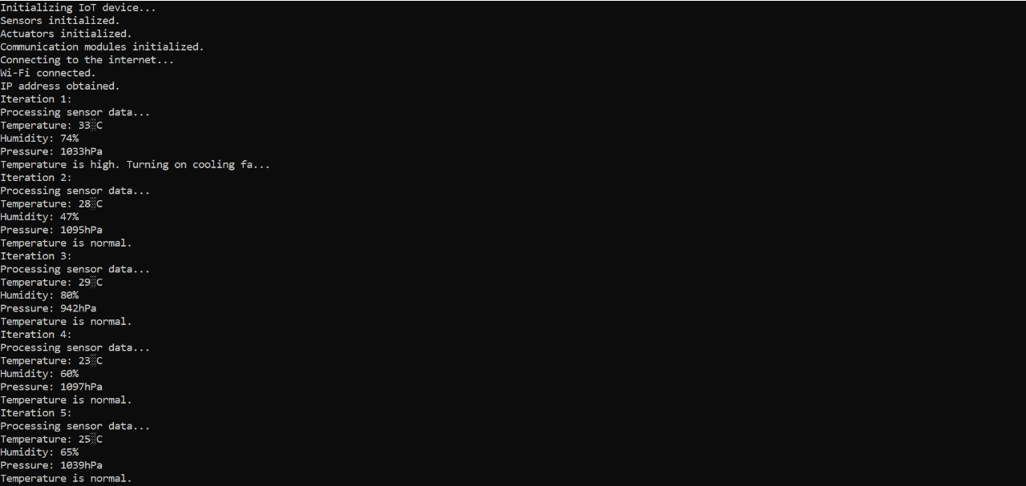

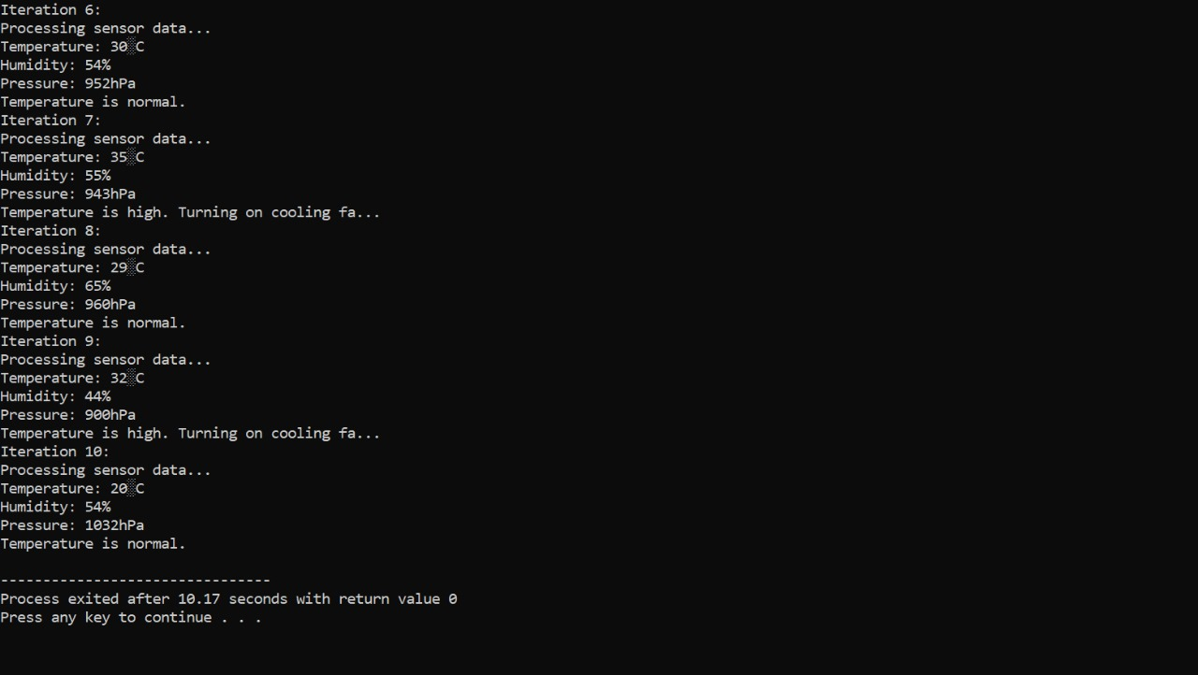

**RESULTS:**

“IoT Development: Unlocking the Power of Connected Devices”delves into the critical realm of creating operating systems tailored for the Internet of Things (IoT) landscape. In this comprehensive guide, the intricate process of crafting embedded operating systems capable of providing real-time connectivity and intelligence to IoT devices is meticulously explored. From understanding the fundamental architecture to implementing advanced features, the book equips developers with the knowledge and tools necessary to navigate the complexities of IoT development. By integrating real-time connectivity protocols and intelligent algorithms, developers can harness the full potential of IoT devices, enabling them to communicate seamlessly, process data efficiently, and adapt dynamically to changing environments. This resource serves as an invaluable companion for professionals and enthusiasts alike, offering insights and strategies essential for building robust and innovative IoT solutions.

**Conclusion:**

In conclusion, IoT (Internet of Things) development is a dynamic and rapidly evolving field that holds immense potential for transforming various industries and aspects of daily life. The integration of physical devices, sensors, connectivity, and data processing has paved the way for innovative solutions with the capability to enhance efficiency, improve decision-making, and create new experiences.

In summary, IoT development is at the forefront of technological advancements, offering transformative solutions across diverse domains. As the IoT ecosystem continues to evolve, balancing innovation with security, privacy, and ethical considerations will be essential for unlocking the full potential of this paradigm-shifting technology.